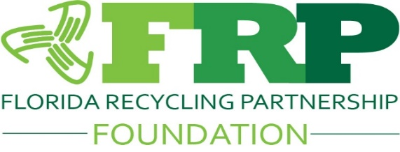
Florida Recycling Partnership Foundation
2026 Recycling Champions Awards Application
General Information
Organization Name: ______________________________________
Primary Contact: ______________________________________
Title: ______________________________________
Email: ______________________________________
Phone: ______________________________________
Address: ______________________________________
Website: ______________________________________
Applicant Type (Check One)
☐ Non-Profit Organization
☐ Small Business (100 employees or fewer)
☐ Large Business (More than 100 employees)
☐ Government Agency
☐ Educational Institution
☐ Individual
☐ Other: ______________________
Program Name

Program Location (City/County)

Program Summary
1. Executive Summary (250 words or less)
Provide a brief overview of the program and why it deserves recognition.

Program Impact
2. Challenge or Opportunity
What problem, need, or opportunity was the program designed to address?

3. Program Description
Describe the program, project, or initiative.
Include:
- Goals and objectives
- Target audience
- Key activities
- Partnerships involved

4. Measurable Results
Provide specific outcomes and metrics achieved.
Examples:
- Tons recycled or diverted
- Reduction in waste generated
- Water savings
- Energy savings
- Greenhouse gas reductions
- Number of participants reached
- Economic impact

Innovation & Leadership
5. Innovation
How does this program demonstrate creativity, innovation, or a new approach?

6. Leadership & Collaboration
Describe any partnerships, stakeholder engagement, or leadership demonstrated through this effort.

Replication & Long-Term Impact
7. Sustainability of the Program
How will the program continue into the future?

8. Replicability
Can this program serve as a model for other organizations? If so, how?

Supporting Materials
Please attach any of the following:
☐ Photographs
☐ Data and Metrics
☐ News Articles
☐ Testimonials
☐ Marketing Materials
☐ Videos or Links
☐ Letters of Support

Recognition Information
9. If selected, who should accept the award?
Name: ______________________________________
Title: ______________________________________
10. Please provide a 100-word summary suitable for publication if selected as a winner.

Judging Criteria (100 Points)
Criteria | Points
Measurable Impact & Results | 30
Innovation & Creativity | 20
Leadership & Collaboration | 15
Environmental Benefits | 15
Replicability & Scalability | 10
Quality of Application & Supporting Materials | 10
Certification
I certify that the information provided in this application is accurate and complete.
Applicant Signature: ______________________________
Date: ______________________________

Scan document and any supporting documents to Keyna Cory at keyna@flrecycling.org
Feel free to include additional pages if needed.
Fee:
$125 for profits
$75 for non-profits; governmental entities
Scholarships are available for non-profit organizations. Please contact Keyna for more information (keyna@flrecycling.org)
Deadline to submit form is noon September 3, 2026
Winners will be announced on October 15, 2026
Awards presented at Florida Recycles Day scheduled for November 18, 2026 at the University of Florida TREEO Center

