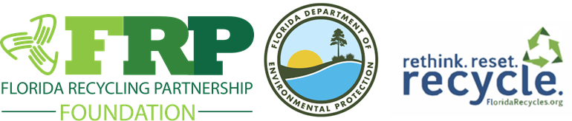
REGISTRATION IS NOW OPEN!
Click here to register!
Wednesday, November 18, 2026 • University of Florida TREEO Center • Gainesville
Join the Florida Recycling Partnership Foundation and the Florida Department of Environmental Protection for a day of ideas, innovation and partnerships focused on strengthening recycling and sustainability throughout Florida.
THIS YEAR’S PROGRAM
SMART RECYCLING TECHNOLOGY  Innovative tools and real-world applications to increase participation, improve collection efficiency and reduce contamination.  Speakers - Alita Kane, Grant Development Manager - The Recycling Partnership and Nick Ciancio, Resilience Division Director, Dept. of Solid Waste Mgmt,– Miami-Dade County  Moderator – Liz DeWitt, President/CEO, Florida Beverage Assn. | RECYCLING IN SPORTS VENUES  How sports venues and their partners are advancing recycling, waste reduction and sustainability.  Speakers include Laura Sivels, Associate, Advisory Services- Sustainability and Environmental Solutions – WM, Christian Bruey – PureCycle and Brazo Barber – PGA Sustainability (invited)  Moderator – John Mitchell, Coca-Cola Beverages Florida
RECYCLING AWAY FROM HOME  Opportunities to make recycling more convenient wherever Floridians live, work, travel and play.  Speaker - Hannah Sackles, Graduate Research Assistant  University of Florida, Herbert Wertheim College of Engineering  Moderator – Karen Moore, DEP | INDUSTRY INNOVATIONS & SUSTAINABILITY  Emerging initiatives, partnerships, challenges and solutions from recycling and sustainability leaders.  Speakers - Dan Penn, Publix and Patrick Krieger, SVP of Sustainability and Policy, Plastics Industry Association
CELEBRATING FLORIDA’S RECYCLING LEADERS
The program will include presentations of the FRPF Recycling Champion Awards and DEP Recycling Recognition Awards.
Registration is now open! Click here to register!
